# Flow Visualization Lab

Ryan Dalby

February 14, 2021

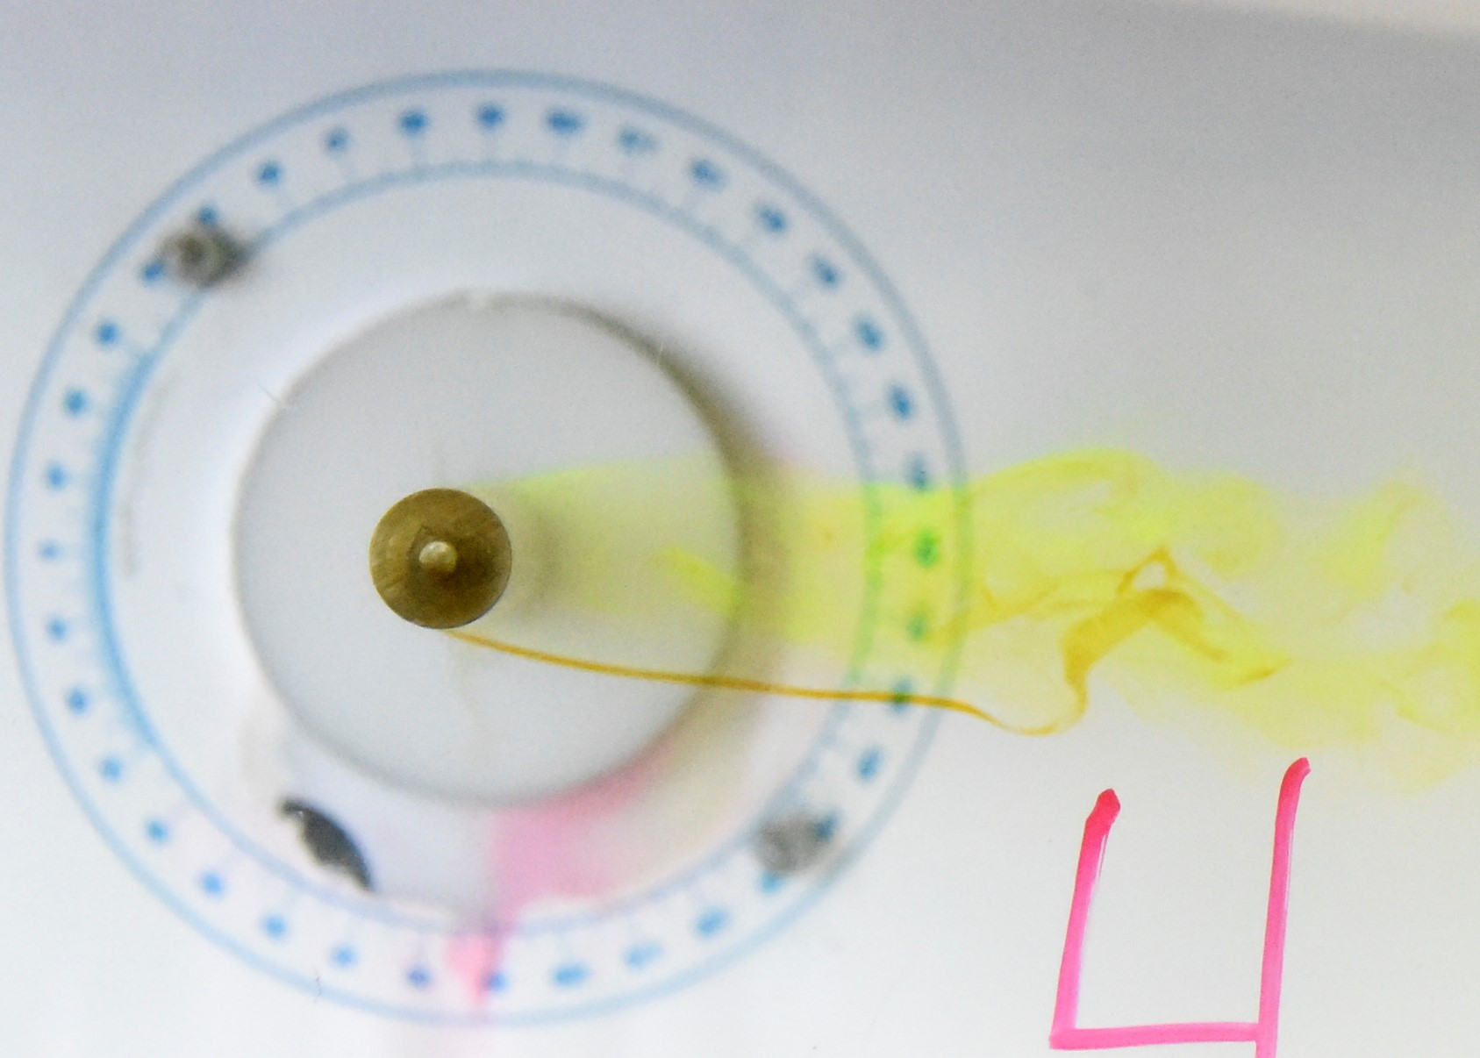

Wake

Stagnation Point

Seperation Point

**Figure 1a.** Streaklines around a circular cylinder at a Reynolds number based on cylinder diameter of $Re_{D}$ =1013.8. The streaklines are marked by neutrally-buoyant dye injected from a small hole at the front of the cylinder. Flow is from left to right.

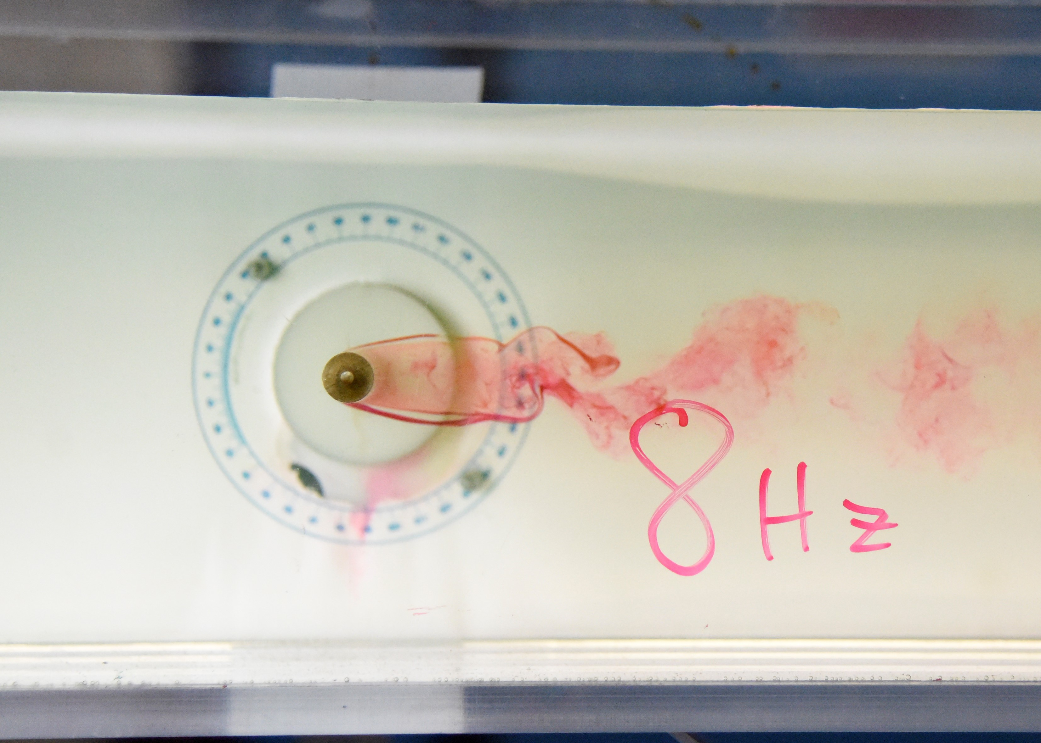 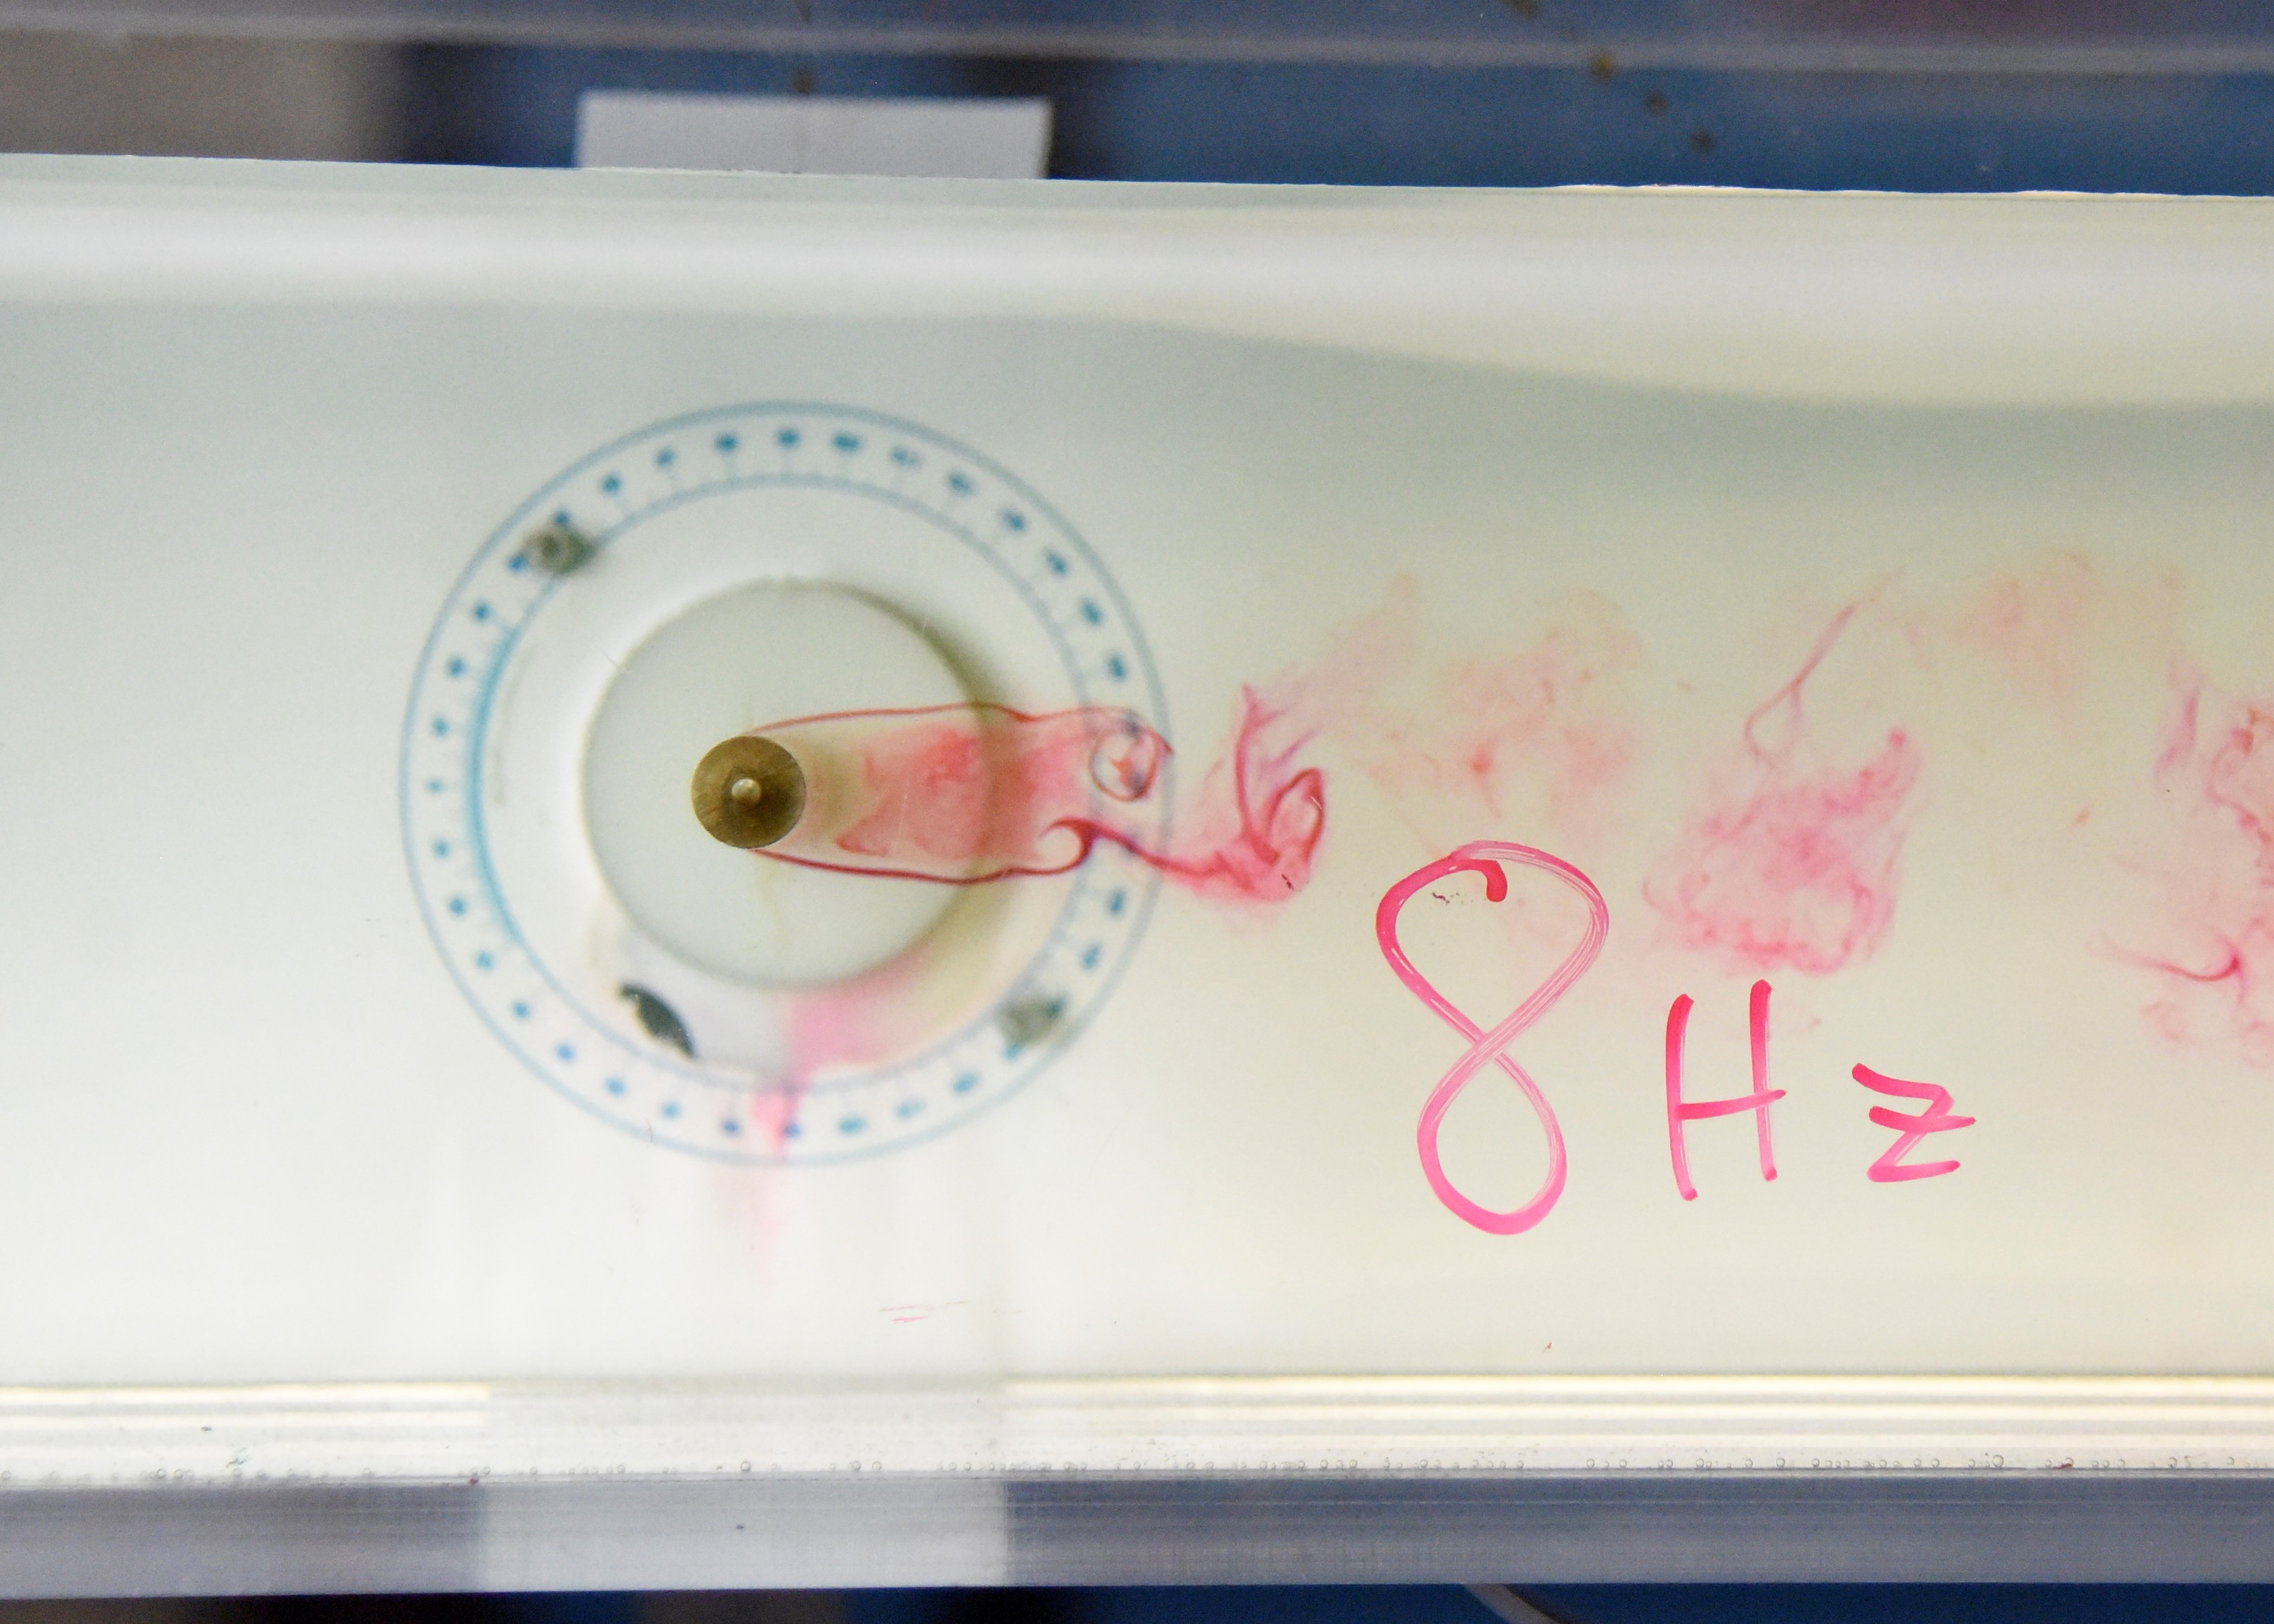

**Figure 1b.** Streaklines around a circular cylinder at a Reynolds number based on cylinder diameter of $Re_{D}$ =2005.5. The streaklines are marked by neutrally-buoyant dye injected from a small hole at the front of the cylinder. Flow is from left to right. A sequence of two snapshots are shown with a time of 4000 ms between each snapshot.

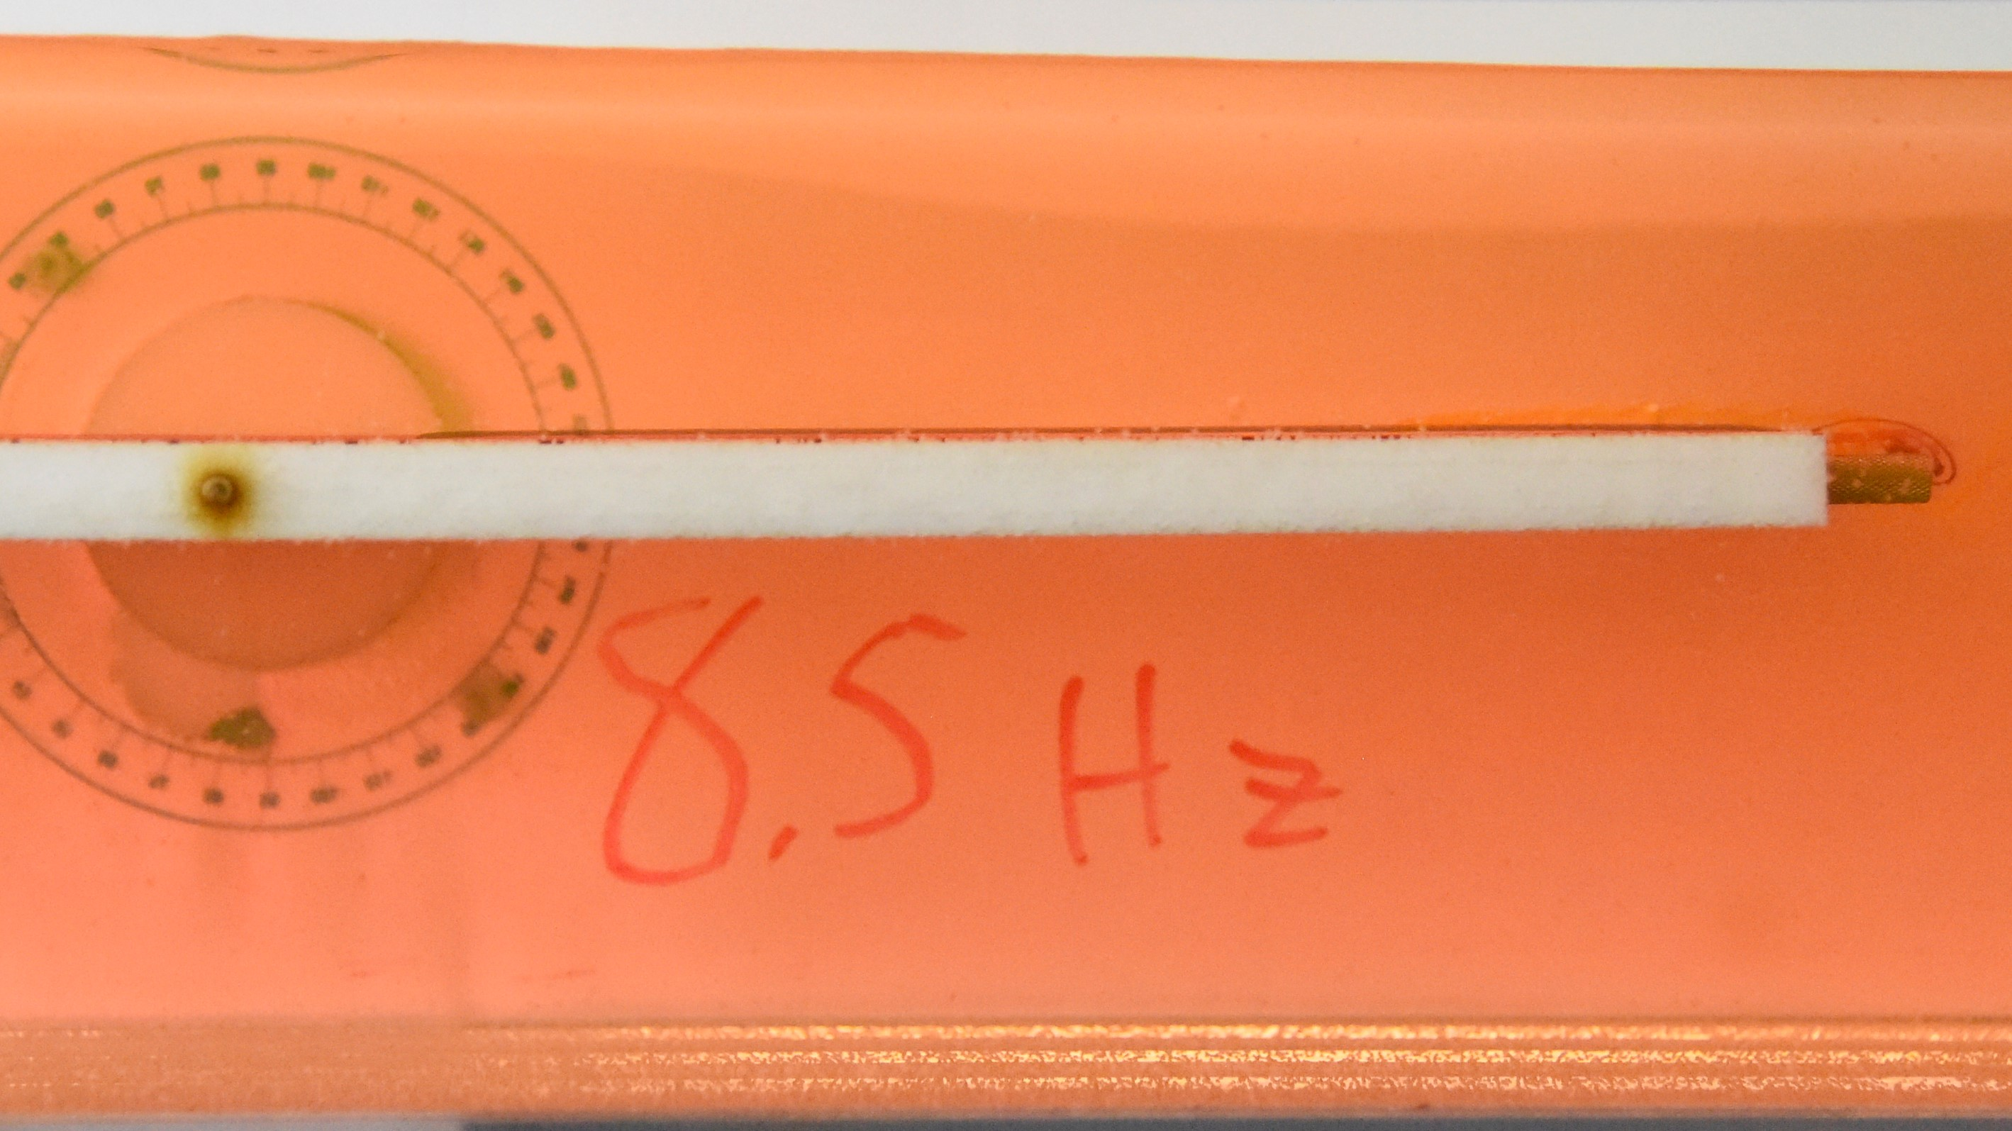

Transition Flow

Transition Flow Begins

Laminar Flow

**Figure 1c.** Streaklines in the boundary layer developing along a flat plate. The streaklines are marked by neutrally-buoyant dye injected from a series of small holes along the plate. Flow is from left to right. The arrow indicates the approximate location of transition from laminar to turbulent flow. At this location, the Reynolds number based on distance from the leading edge of the plate is $Re_{x}$ =67076.4.

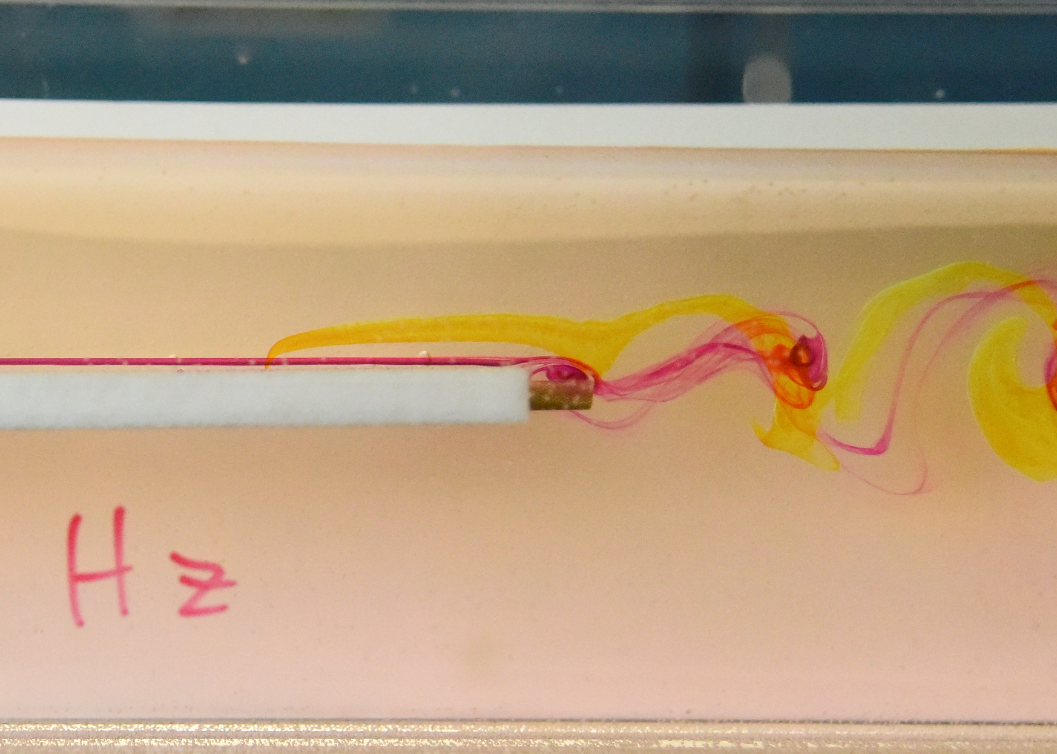 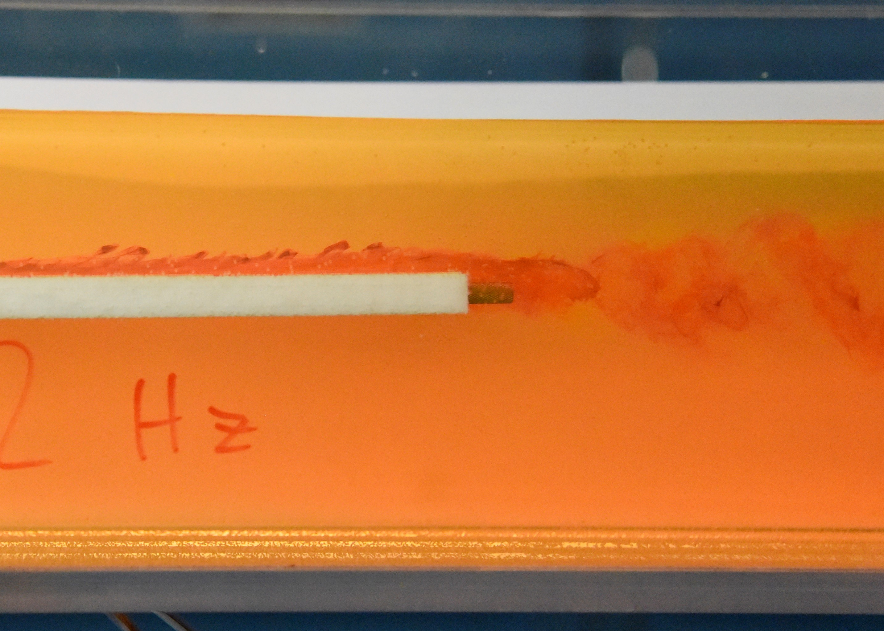

**Figure 1d.** Streaklines in the boundary layer developing along a flat plate: (left) laminar case, (right) turbulent case. The streaklines are marked by neutrally-buoyant dye injected from a series of small holes along the plate. Flow is from left to right.

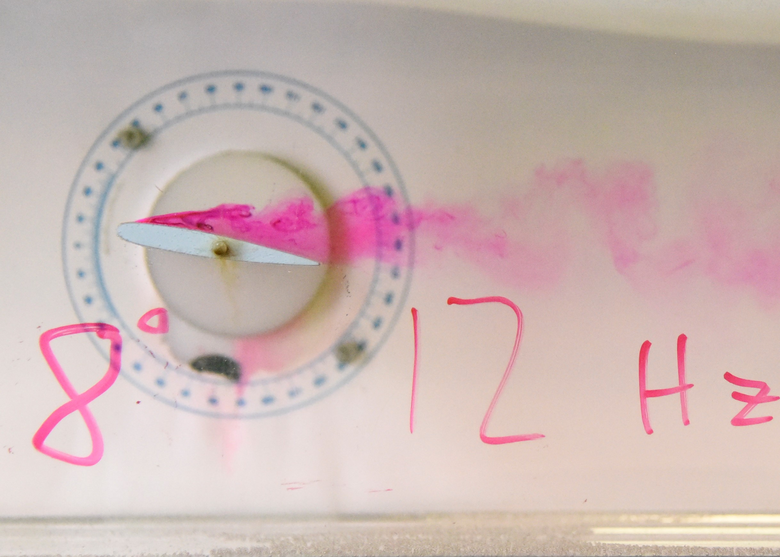

Vortex Shedding

Separation Point

Recirculation Region

**Figure 1e.** Streaklines around an airfoil at an angle of attack of 8o and Reynolds number based on chord length of $Re_{c}$ =10005.1 The streaklines are marked by neutrally-buoyant dye injected from a small holes along the surface of the airfoil. Flow is from left to right.

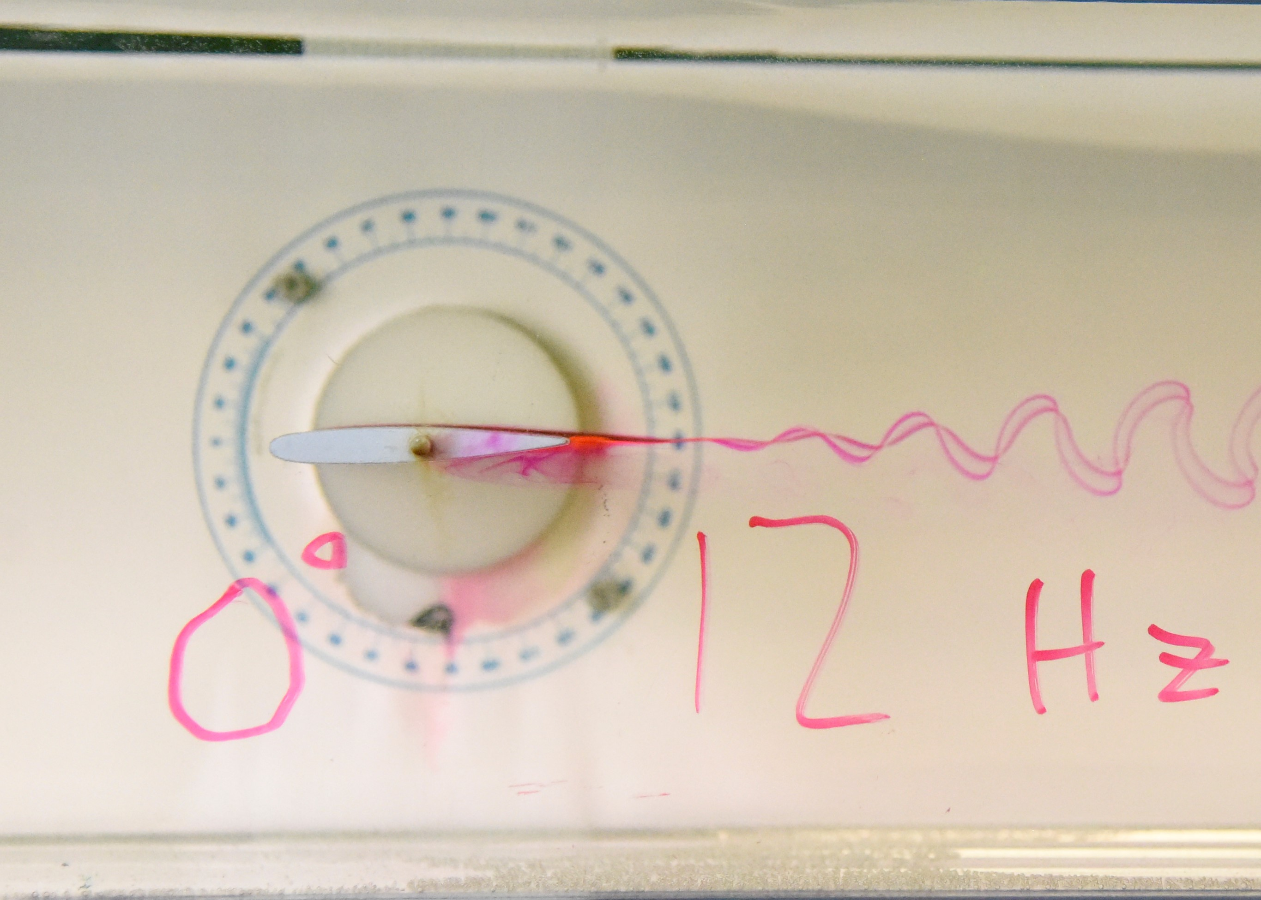 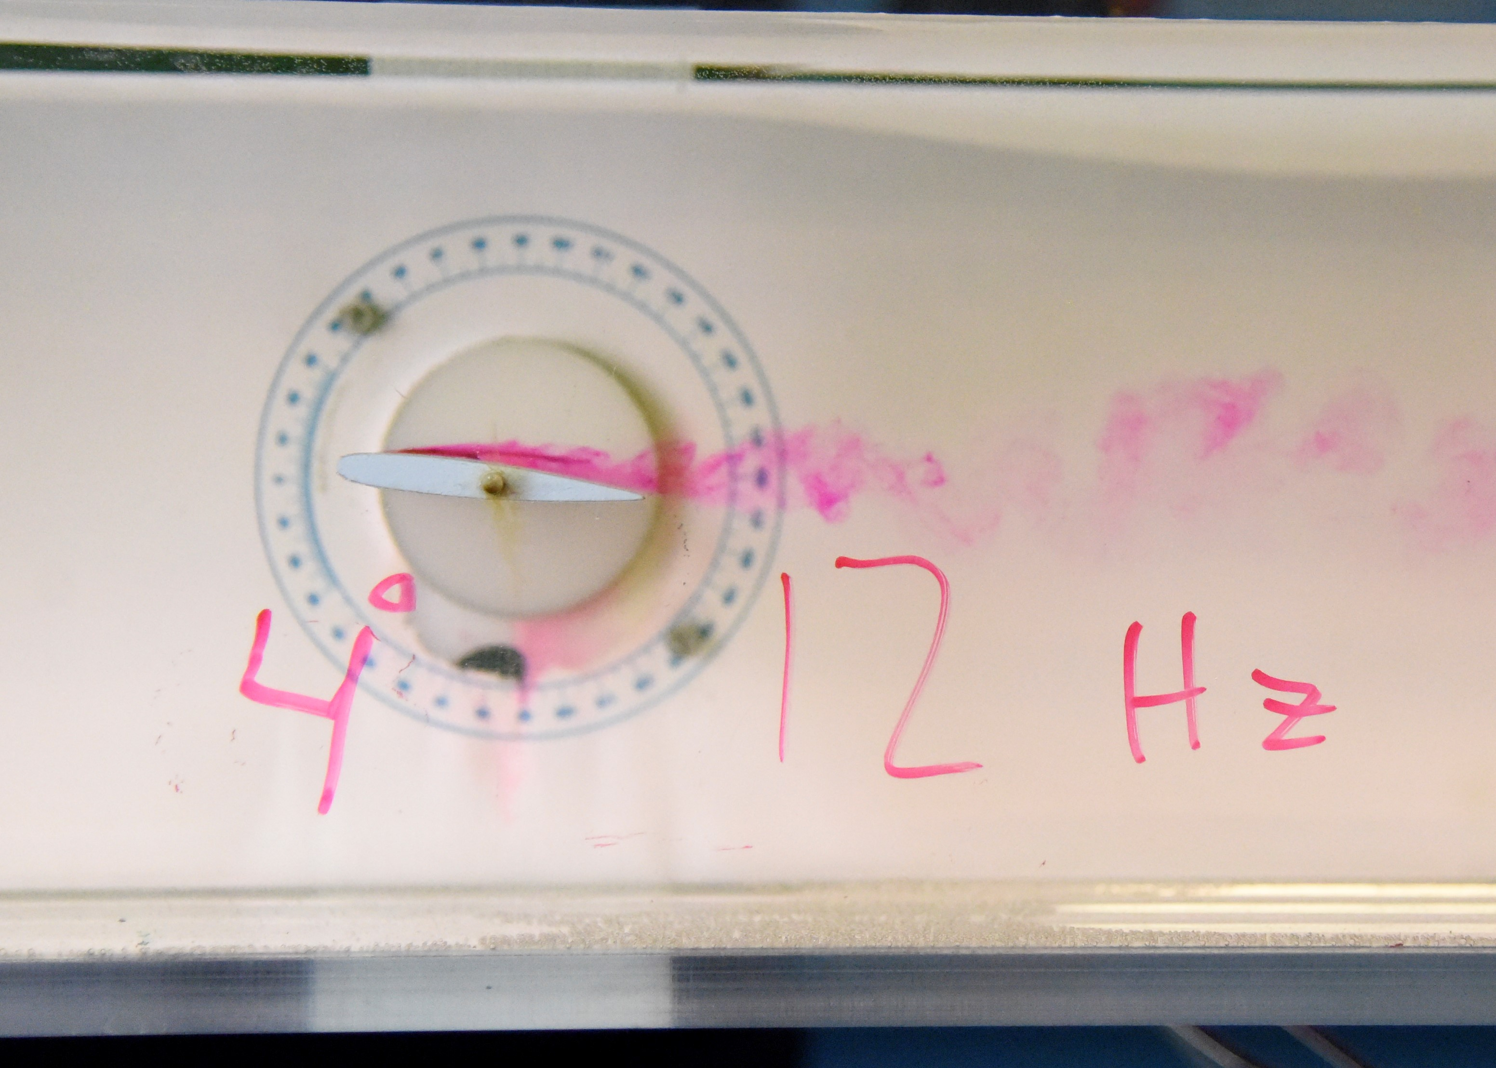 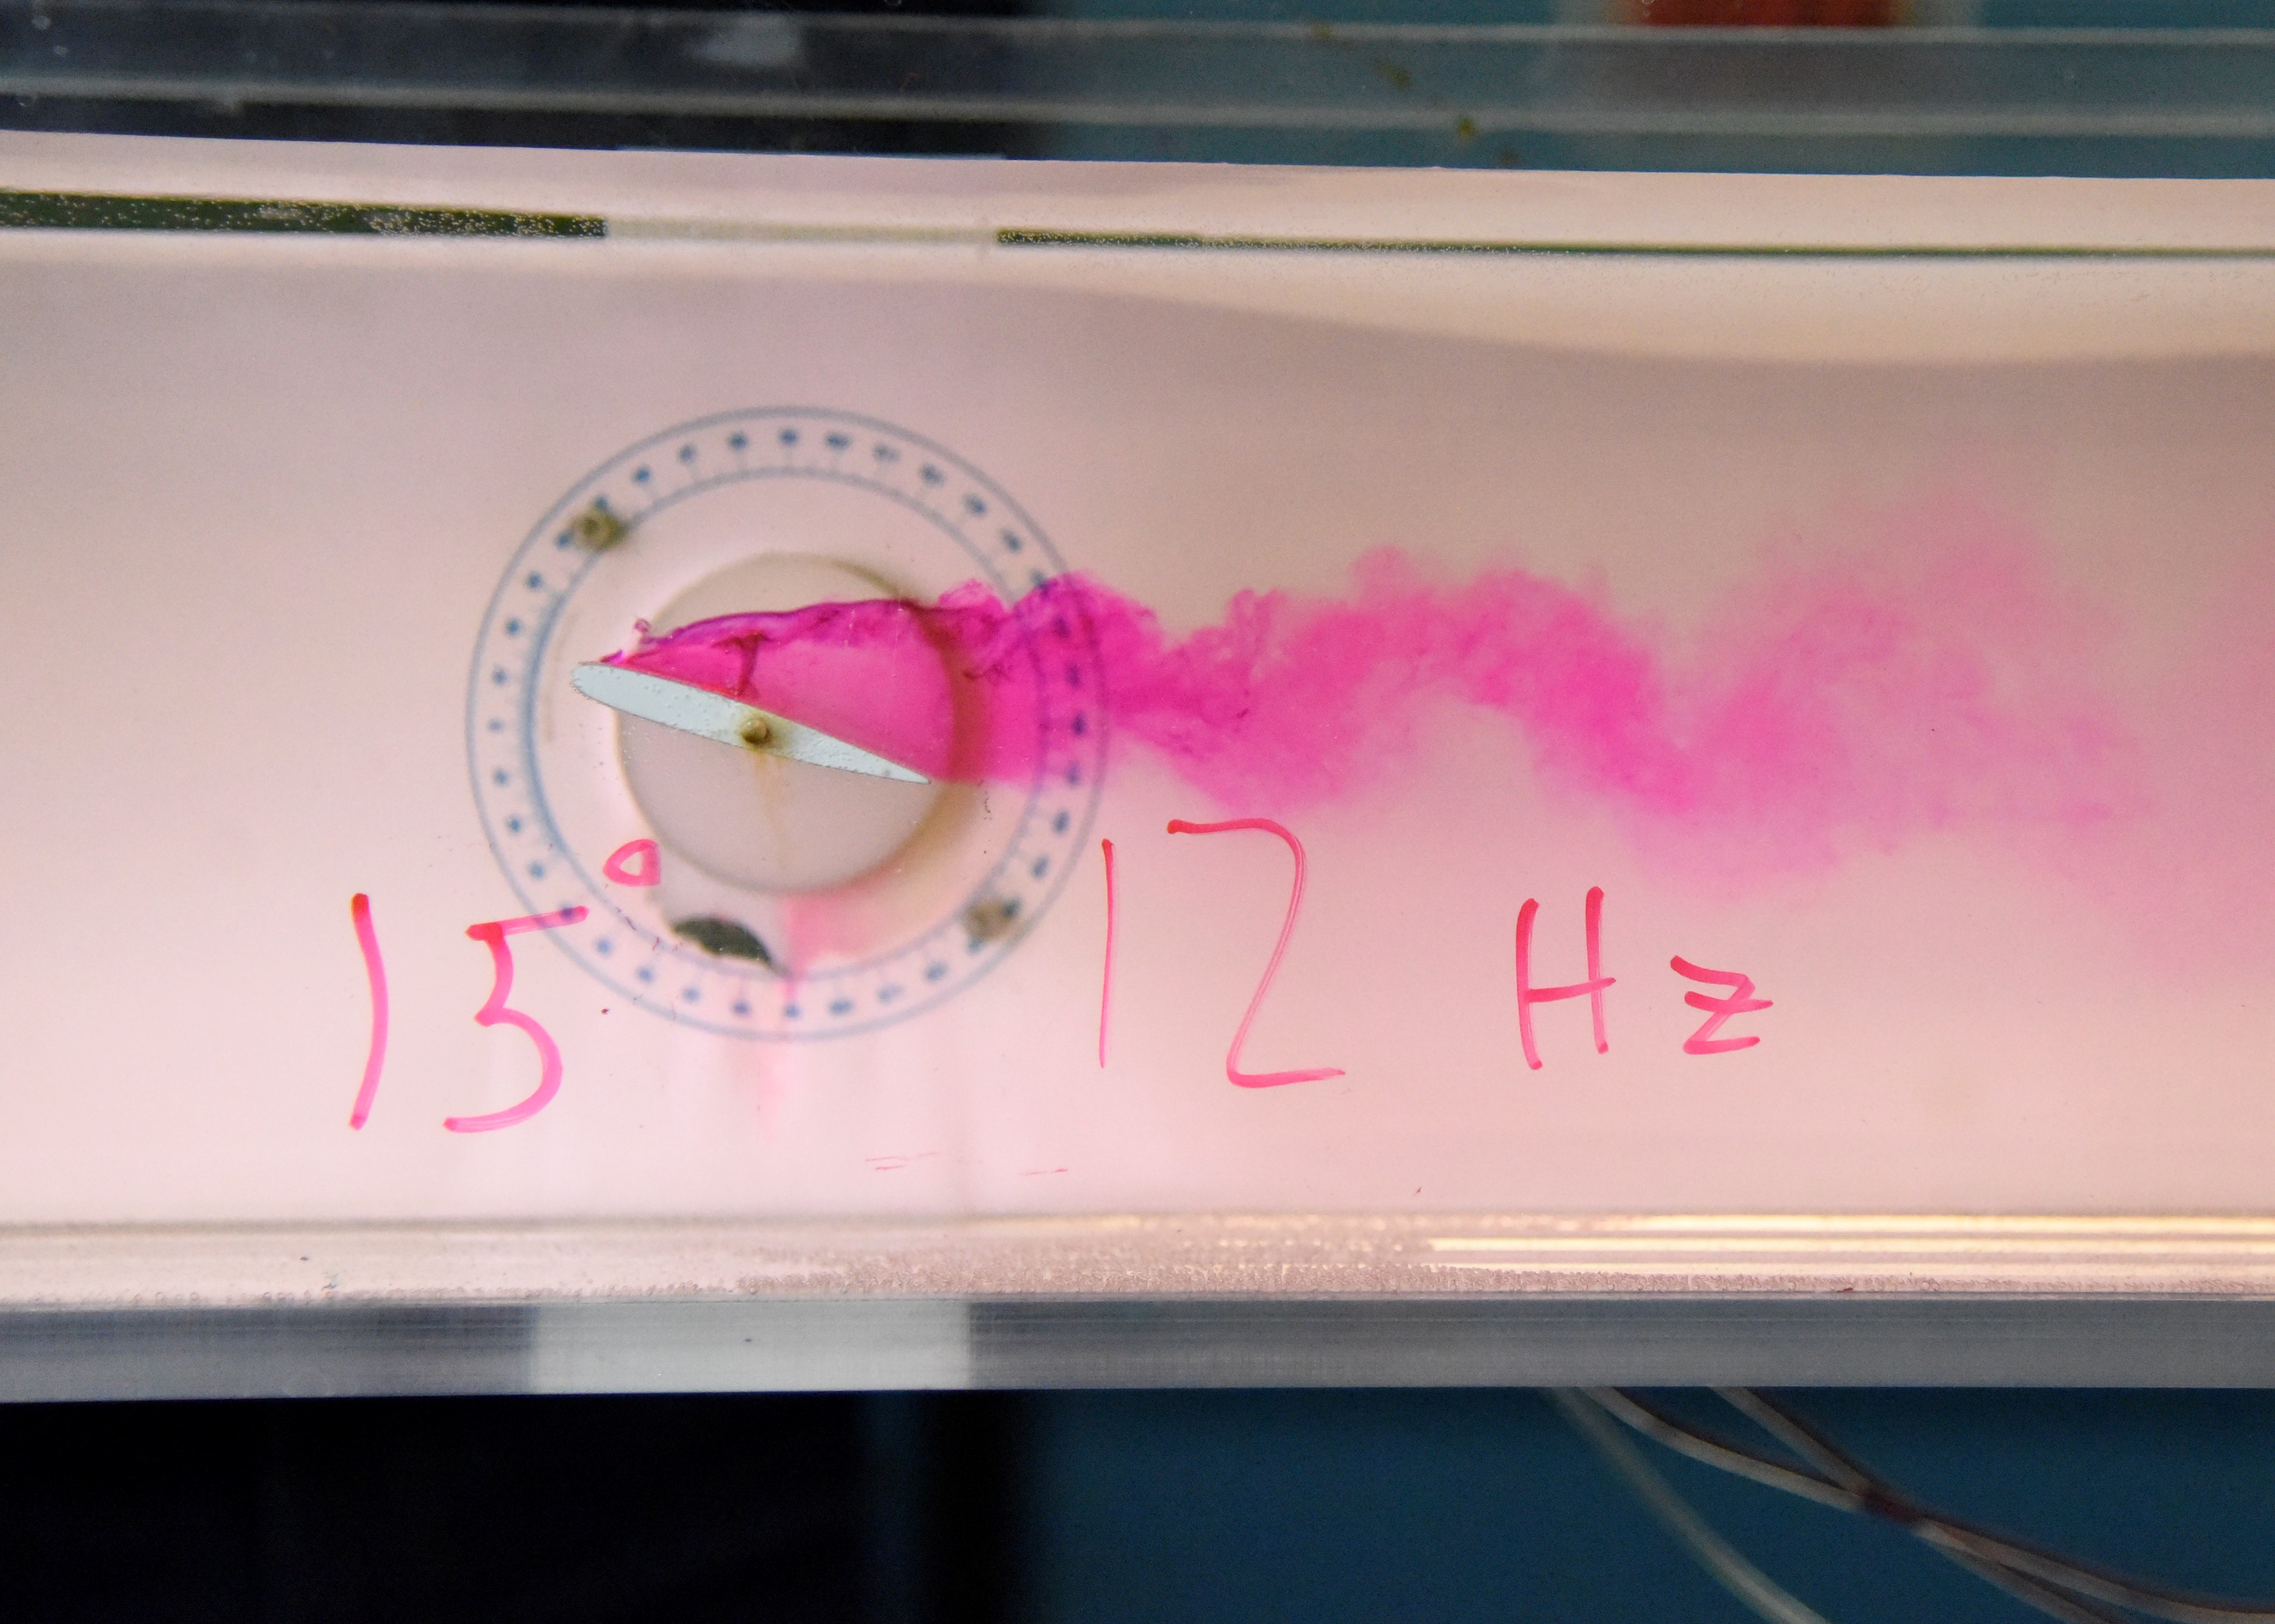

**Figure 1f.** Streaklines around an airfoil at a Reynolds number based on chord length of $Re_{c}$ =10005.1, and three different angles of attack: (left) 0o , (middle) 4o, (right) 15o. The streaklines are marked by neutrally-buoyant dye injected from a small holes along the surface of the airfoil. Flow is from left to right in each image.

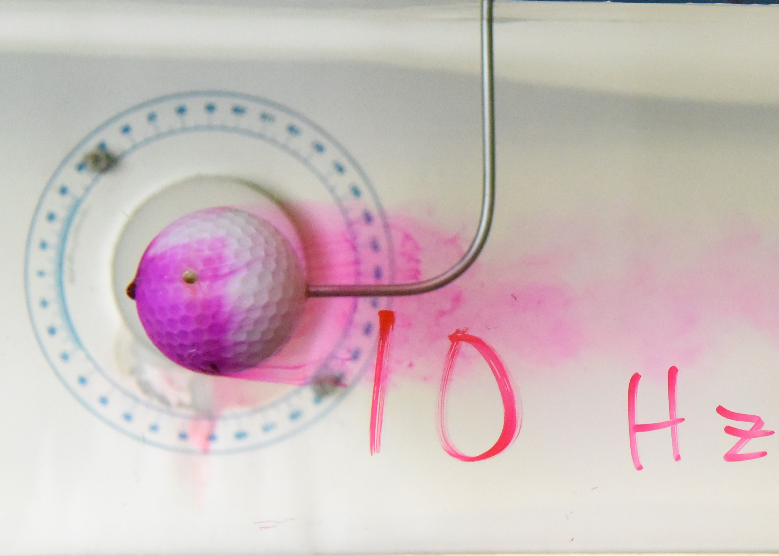 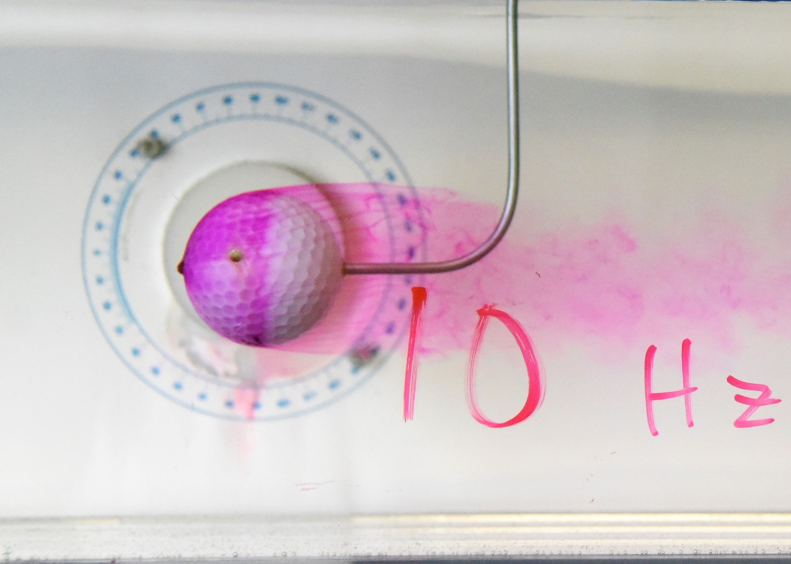 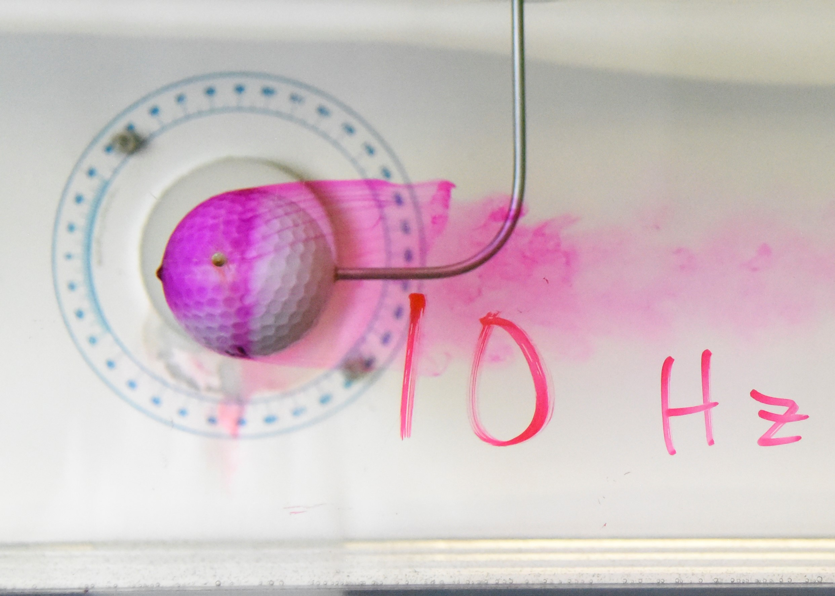

Separation Point

Wake

Stagnation Point

**Figure 1g.** Streaklines in the flow over a golf ball. The streaklines are marked by neutrally-buoyant dye injected from a small hole on the front of the golf ball. Flow is from left to right. The Reynolds number based on golf ball diameter is $Re$ = 8404.2504. A sequence of three snapshots are shown with a time of 2000 ms between each snapshot.

**2a.**

For the circular cylinder there were distinct differences between the low Reynolds Number flow of $Re_{D}$ =1013.8 shown in Figure 1a and the high Reynolds Number flow of $Re_{D}$ =2005.5 shown in Figure 1b. One distinct difference is the size of the wake, which is bigger for the higher Reynolds Number flow and directly related to the earlier separation point for the flow when compared to the lower Reynolds number flow. A second observation is the vorticies which are found in the wake of the flows. For the low Reynolds Number flow the vorticies and the overall appearance of the wake is less turbulent than the high Reynolds Number flow. This indicates the high Reynolds number flow is more viscous, especially in the wake region, even though both flows are viscous in the wake region. In the end, both flows have a similar stagnation points and overall shape. The differences between the flows would be clearer with a more drastic difference in Reynolds number.

**2b.**

A few of the limitations of dye-injection flow visualization is that the injected dye material or injection probe may influence the flow (Löffelmann) and dye-injection gives an indication of streaklines rather than streamlines and pathlines. (These three are only equivalent when the flow is steady.) A potential alternative to this flow visualization technique is Particle Tracking Velocimetry or PTV. This technique allows for volumetric velocity measurements within a fluid flow by suspending micron-size particles in the fluid and imaging the motion the individual particles trace out (Pecora). PTV can enable pathlines to be visualized even in unsteady flow and has good spatial resolution. For this lab, PTV could enable more resolution in determining the exact locations of different fluid phenomenon and provide more accurate measurements of the size of the boundary layers which could be useful engineering a body for moving through flow in a desired way. The downside of PTV would be that it would be more complicated than dye-injection and would require more specialized equipment to obtain a PTV visualization.

**References**

1. H. Löffelmann, “Flow visualization,” *State of the art - flow visualization*. [Online]. Available: https://users.cg.tuwien.ac.at/helwig/diss/node10.htm. [Accessed: 15-Feb-2021].
2. C. Pecora, “Particle Tracking Velocimetry: A Review,” 2018.